**Version 1**

**EvoSim**

**User Documentation**

**Lukas Kikuchi**

Table of Contents

Introduction 2

Overview 3

Simulatory Components 3

The User-Interface Components 5

Simulatory Components 6

Simulation 6

Entity Drawing-Options 6

Templates 7

World 7

Entities 9

Creatures 10

Genome 10

ANN 10

How to Make a Simple Simulation 11

# Overview

## Simulatory Components

Here I’m going to go through the basic-parts of the application, so that you get an understanding on as to how the program works.

**Simulation**

This is what the application will run. You create a simulation, you run it, you save it, you close it, and then load it up again and continue running it.

A simulation contains a…

**World**

The world is the thing that the artificial creatures live within. It looks like this:

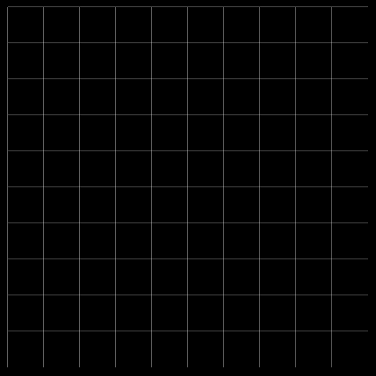

It’s not much too look at…

It’s made up of a grid, with a specified cell-size. The cells within the grid are called **regions**. You usually don’t need to care much about the regions, as they don’t affect the simulation in any way. The size of the regions can affect performance a bit though.

The world is inhabited by…

**Entities**

Not only creatures!

All objects that exist on the map are referred to as *entities*. The artificial creatures are entities, and also the foods that the creatures eat are entities.

**Creatures**

They are the artificial life-forms that live within the world. They are made up of two different things:

* Genome
* ANN

The *Genome* decides the physical parameters of the creature. The *ANN* is the brain of the creature. Besides these two things there are also different Creature-types, the most basic Creature-type is *Creature*.

**Templates**

Whenever you want to add a creature to the world, you have to do it through the use of *templates*. More specifically, you need to use 3 different templates:

* Creature-template
* Genome-template
* ANN-template

A creature, a genome or an ANN has loads of different parameters and options that can be adjusted. Templates are stored configurations of the parameters, which allow quick mass-production of creatures with the same configuration.

There are also world-templates, and entity-templates, we’ll go through these in more detail later.

# The User-Interface Components

The user nterface of the simulation is not overly complicated; it has three main elements, as you see in the picture.

1. This is the menubar, where most of the simulation management occurs.

**File** is where you save or open simulations.

**Edit**

**Simulation** allows you to change simulation-settings, that mostly effects how information is presented to you rather than affecting the actual simulation.

**World** is where you edit or manage the world.

**Entities** allow you to edit and add entities or creatures to the world.

**Templates** allow you to manage all of the different templates.

**Tools** hold a bunch of analytical tools.

**Help** is pretty self-explanatory isn’t it?

1. Here’s the world map, the green circles are food-entities.
2. The sidebar is where quick-information about a selected entity is displayed.

# Simulatory Components

## Simulation

To begin simulating these lifeforms you need to create a *simulation*. A simulation is what contains all the simulation data that you run, the simulation is what you save and load on your harddrive.

A simulation doesn’t have that many attributes: the *world* that it simulates, the name of the file, and also drawing options for all the entities and creatures.

To create a new simulation you just go into File->New Simulation.

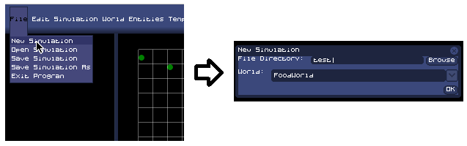

### Entity Drawing-Options

You can choose between different ways to draw your entities, you do that by assigning an *entity-painter* to a specific entity type. Different entity-painter draws in different ways, and many entity-painters can only be assigned to a specific entity.

If you go to Simulation->Entity Draw-Options you get to the menu where you can manage all the entity-painter settings.

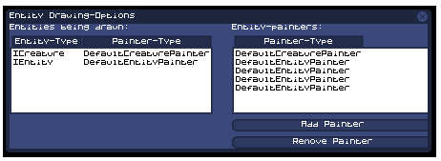

Here you can add or remove painters. The left panel shows which entity-types are being drawn by which entity-painters, the right panel shows which entity-painters are active at the moment.

To assign an entity-painter to an entity, you must click the add painter button, and you get to this form:

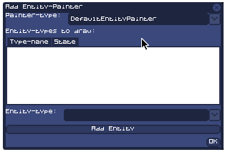

Here you choose what entity-painter-type to use, and then you select which entities it is supposed to draw, and then you just click *ok* to add it!

## Templates

Everything within the simulation is created through templates. What are templates? Templates are ready-made configurations of different parts of the simulation, like; worlds, entities or ANNs.

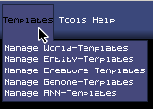

If we click on *Manage World-Templates* we get this:

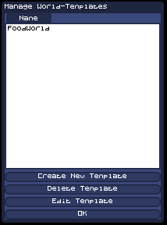

Here you see that there is one preexisting template already there, you can create a new one by clicking on *Create New Template*.

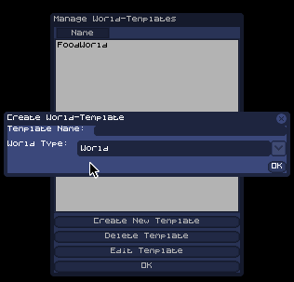

Before getting to the part where you can configure the world-template’s parameters, you first have to decide what name the template should have and what kind of world-type it should be. After your done you can click *ok*, and you get to the part where you edit the paramters.

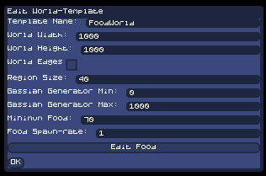

When you’re done click *ok* and you’ve got yourself a new template!

## World

The world is the artificial selective environment that the creatures live within; it’s a 2D surface that is composed of a gridnet. The cells within the grid are called **regions**, and when you create a new world you get decide the size of these regions (the regionsize doesn’t affect the simulation at all, except performance-wise).



Whenever you create a new simulation, you have to choose what kind of world you want to simulate. There are different world-types, that all work differently. The two default world-types are:

* *World*, is just a 2D landscape that can hold different entities.
* *FoodWorld*, automatically spawns food onto the map.

If you go to World->Edit World, you can change the currently simulated world’s properties. This particular window is for a FoodWorld.

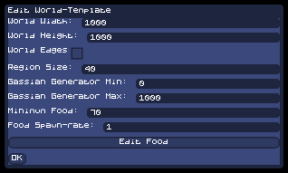

If you edit a world-template you get this window:

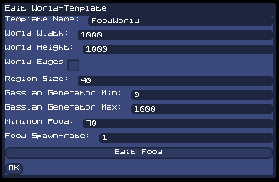

This is exactly the same window.

## Entities and Creatures

Entities is the common name for everything that exists within a world, different entities have different properties and they all serve completely different roles within the simulation.

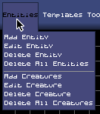

Here you can see what you can do with entites; you can add them, edit their properties, delete them or choose to delete all of them. Handling Creatures work much the same way as handling entities.

If you want to add an entity you get this window:

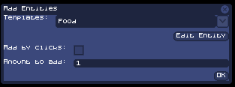

You have to choose between different entity-templates, and you can also customize the template specifically by clicking on *Edit Entity*.

If you check *Add by Clicks*, the entities are spawned whenever you click with the left mouse button, to turn that off you click the right mouse button. If you let it go unchecked you instead have to specify the amount of entities should be randomly spawned across the map.

To delete an entity you first have to select which entity to delete by clicking on it in the map and then clicking Entities->Delete Entity.

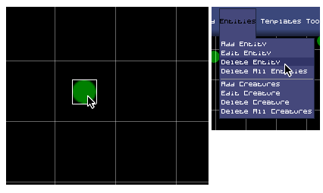

Editing an entity works much the same way, you just click Entities->Edit Entity.

## Genome

For evolution to occur, creatures need to have a genome that they can pass on through generations. Luckily, this simulation isn’t lacking in that department!

When you create or edit a genome-template you get this window:

## 

This is also the window get whenever you try to edit a genome, if you click *Edit Body-genes* you can edit the color of the creature.

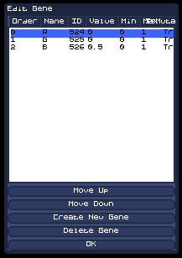

Here you see three different genes, one for the color red, one for the color blue, one for the color green. You can edit the genes by double-clicking them. You can also delete the genes, if you don’t want the creatures to have them at all.

If you click *Edit Mutation-Genes* you get a similar window:

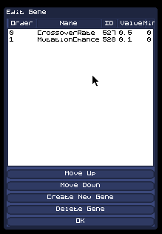

These two genes are parameters that figure into the mating processes of the creatures, *CrossoverRate* decides the rate of gene-crossover between the two creature’s chromosomes; *MutationChance* decides the rate of gene-mutation.

The genome actually only deals with the physical genes of the creature, for the ANN there is a separate ANN-chromosome.

## ANN

The ANN within the creature is stored within an ANN-chromosome, encoded in genes. If you edit an ANN-tempalte you get a window like this:

## 

*Inhibitory Connection-Chance*: The chance of a random connection being inhibitory.

*Connection-Chance:* The chance of a connection occuring between two neurons.

*NewConnectionsCanForm*: If checked, neurons can mutate and form new connections.

*ConnectionCanDie*: If checked, neurons can mutate and kill connections.

*NeuronsCanDie:* If checked, neurons can mutate and die.

Just like the genome, the ANN-chromosome has Mutation-Genes.

The sigmoids of the ANN can be configured and changed between different types; you also have two different sigmoids, one for output-neurons only and one for the rest of the neurons.

If you click *Randomize*, you get a random brain generated with the parameters you choose.

If you click *Edit Neuron-Genes*, you get to edit all of the genes within the ANN manually.

# How to Make a Simple Simulation

Here we are going to go through the process of making a simple simulation, using the default templates that initially come with the application.

Here is your initial screen when you start the program, notice the *“No World”* notation in the world-screen, we want to change that to a view of a simulated world.

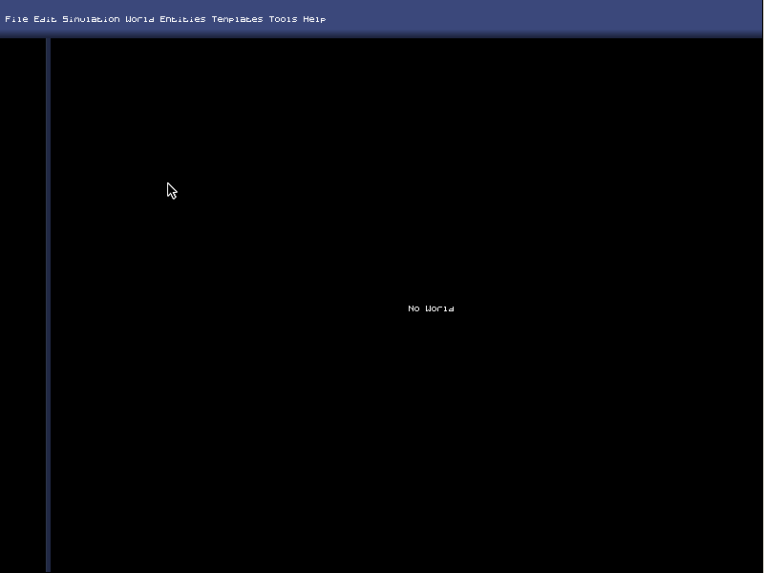

To create a new simulation, click *File->New Simulation*. You’ll get this dialog-box:

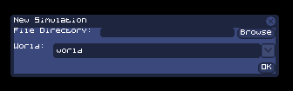

In *File Directory* you are supposed to write the file-name of the simulation will be saved as. You can click the *Browse* button to browse to a specific directory, or just write the directory and file-name manually. If you do not start the name with *“C:/”*, the root directory will automatically be the program-directory.

Below *File Directory* there is the *World* combo-box. Here you choose between different World-templates that exist. Choose one and then click ok. If you haven’t created any World-templates you can use any of the pre-existing World-templates that come with the program.

After you’ve clicked ok you have basically created an empty world:

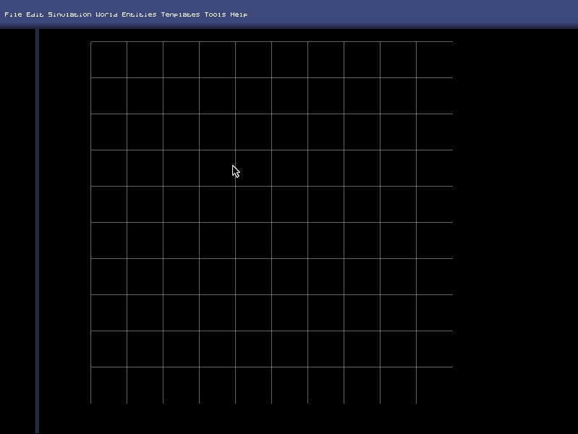

Now we’re going to add some entities, we’ll start by adding some Food.

Go to Entities->Add Entity, you’ll get this dialog-box.

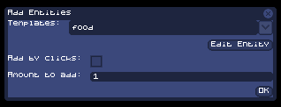

Select what entity-template you want to use, in the *Templates* combo-box. Because we want to create food, you have to choose a template which is of a food type. You can either use the pre-existing template called *food* or use one of your own.

If you want to change the parameters of the entity you want to add, click the *Edit Entity* button, you’ll get a dialog-box in which you can manually change all the parameters of the template. All the changes you make to the template are temporary changes that only apply to the entity you’re currently adding.

The *Add by Clicks* decides whether you’re going add the entities using “clicks” (clicking on the world-map to add creatures) or by randomly placing a set amount of the entity across the map. If you choose to add using clicking, you don’t need to worry about the *Amount to Add* integer-field. **Note: You exit add-by-click-mode by right-clicking.**

The *Amount to Add* integer-field decides how many entities you want to add to the world-map, after you press Ok, that many entities will be distributed randomly across the map.

Press Ok and the map will be filled with food!

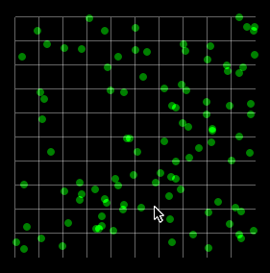

Now we want to add creatures into the mix, this is a bit more complicated (just a bit though!). Click *Entities->Add Creatures*, you’ll get this dialog-box:

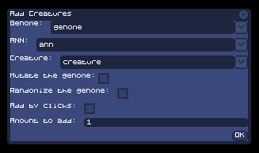

This dialog is pretty similar to the *Add Entity* dialog, but with a few added parameters. Because a creature consists of two main things: The Genome and the brain (ANN) You need to decide on which templates you want to use for the different parts of the creature. After that you need to decide on a Creature-type template.

As mentioned earlier, use the pre-existing template that comes with the application or use one of your own templates.

If the *Mutate the genome* checkbox is checked, the *genome* and the *ANN* will be mutated before being added. If you choose to add 100 new creatures, each of these creatures will be mutated (differently) before being added.

If the *Randomize the genome* checkbox is checked, the *genome* and the *ANN* will be totally randomized before being added. Instead of just slightly mutating the genome of the creature it will instead be completely randomized. If you want to create a world where you want an initial gene-variation, you should check this checkbox.

The *Add by clicks* and the *Amount to add* parameters works the same way as when adding an entity.

After you’ve added some creatures you’ve got yourself a full-fledged simulation!

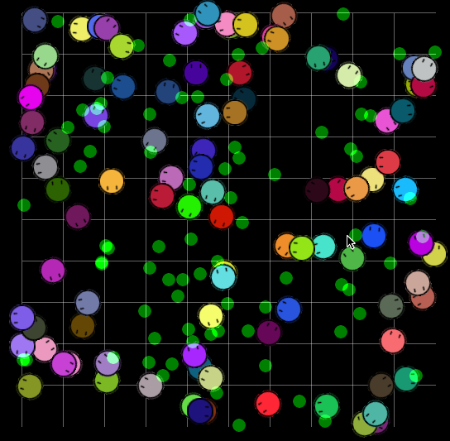

Please note though that in order to actually create a simulation where all the creatures don’t die after 5 minutes you have to do some serious calibration. That is why it is recommended to use the pre-existing and pre-calibrated templates.